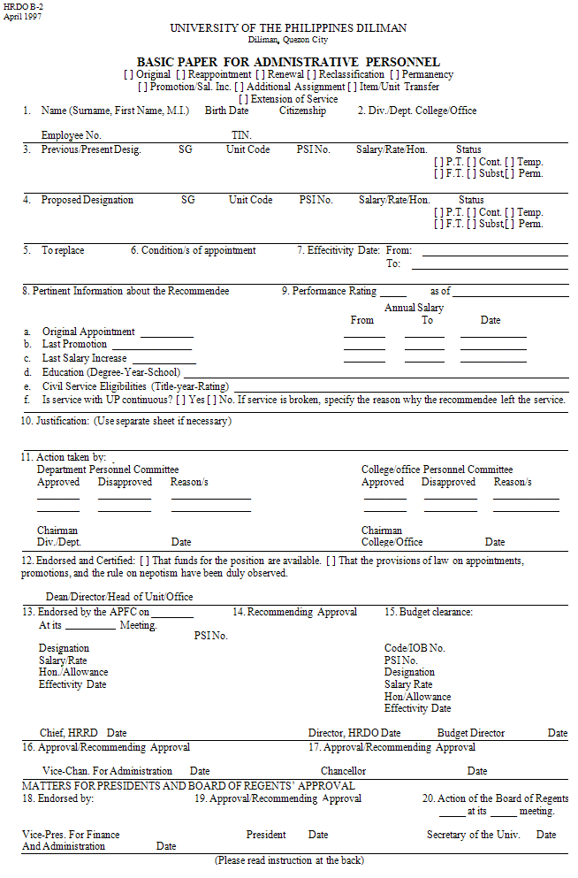
INSTRUCTIONS

- GUIDELINES

- Recommendations for original appointment/reappointment must be submitted at least 1 month before effectivity date.

- Recommendations (original, reclassification, salary increase/promotion) from salary grade 7 and higher including permanency (lowest to highest salary grade) need UP administrative Personnel and Fellowship Committee (UPAPFC) endorsement. However, appointments for administrative staff from s.g. 6 and below, except permanency (all grades) are delegated to Deans.

- Existing policies on hiring, promotion/salary increase must be strictly followed before preparing recommendations for appointment.

- This basic paper must be completely processed and budget cleared by the office concerned before preparations of the notice of appointment by the college/unit under delegated authority.

- Prepare two(2) copies of the basic paper, duplicate copy to be retained in your file.

- Notice of appointment/contract approved by the Dean under delegated authority must be prepared in 7 copies, distributed as follows: original copy – appointee, 2nd copy with all supporting documents – HRDO, 3rd & 4th copies – Payroll/COA, 5th copy – College, 7th copy – CSO.

- Upon release of appointment papers/contract, furnish HRDO (as Repository of records 2nd copy with all the supportment documents (original copy of b.p., information sheet, transcript of academic duly authenticated, medical certificate, police clearance, transfer papers if transferee).

- STEPS IN THE APPOINTMENT PROCESS

Boxes 1 to 13 must be accomplished completely by the recommending unit. Never leave any box blank; otherwise, recommendations should not be accepted by the next office/college unit. Thereafter, the paper shall be acted upon in the sequence of the remaining numbered boxes.

- FORMS/DOCUMENTS REQUIRED

Basic Paper (HRDO B-2) for administrative personnel must be prepared in two (2) copies by the recommending unit. It shall be submitted with the following supporting papers/documents:

- CS Form No. 212 (Revised 1982) – 2 copies 2) Tax Identification Number (From BIR)

- Two (2) Passport-size picture 4) Position Description From – 2 copies

- NBI and/or police clearance – 1 copy 6) Medical certificate with documentary stamp – 1 copy

7) Approved transfer, including the following documents, if the recommendee is from another government
agency/institution or UP autonomous campus:

- Complete statement of service record – 2 copies
- Certification of leave credits, if any – 2 copies
- Certification of last salary received, with corresponding deduction/s – 2 copies
- Clearance – 2 copies

8) Transcript of academic records duly authenticated for salary grade 6 and above.

ADDITIONAL ASSIGNMENT – The following requirements must be submitted:
- Basic paper (HRDO B-2) – 1 copy

- If the additional assignment is as lecturer, Senior lecturer, and other teaching positions, HRDO B-1 must be used – 1 copy

- Endorsement of the Dean/Director/head of the appointee’s home unit if the additional is in another unit on Box No. 13.

- Xerox copy of the approved project, if any – 1 copy

- Justification for the honorarium/allowance/compensation and approved authority, if any – 1 copy

